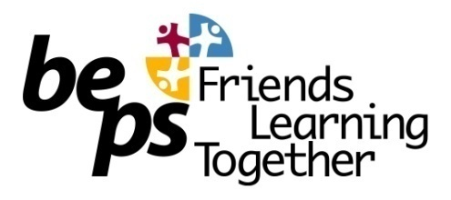

Important Information for Parents about OSHC Payments for 2016

Dear Parents/Guardians,

From the beginning of 2016, all payments for the OSHC program at BEPS, will be by an online system called Qkr. The system is designed to allow parents to pay for OSHC services through a user friendly App. called Qkr.

We believe that paying electronically for the OSHC program will have advantages….There will not be any confusion about whether you are paying for OSHC or other school activities.

So, again we advise that, from the beginning of 2016 ALL OSHC payments will be via the Qkr App. No payments will be accepted by cash, cheque or over the counter at the school office.

To avoid disappointment, when you are told that we cannot take payments at the school office, please take a moment to read this information.

The following is more information on the Qkr App
Qkr! by MasterCard can be downloaded for free from Apple’s app store for iPhones (iPads should download the iPhone app) or from Google Play for Android phones and tablets. After downloading the app and registering, simply tap the magnifying glass in the top right of the Qkr home screen, type QKRPS2, create a fake child profile. You are able to make a transaction on this school and your card will not be charged for this purchase as this demo account does not have true payment credentials.

The following video is an introduction to Qkr and what it can be used for.
https://www.youtube.com/watch?v=42Ir56ghY6Y&feature=youtu.be

Mill Park Heights Primary School Principal and Business Manager discussing Qkr
https://www.youtube.com/watch?v=I54K6Y71aw4

Yours sincerely,

Janet Di Pilla
PRINCIPAL

